|  |
| --- |
| **Increasing student agency in elections:**  **the “Why Vote?” Tool** **Student facing handouts:** Handout 1: Draw your block  Handout 2: Vocabulary  Handout 3: Government services/key issues  Handout 4: Choosing important issues  Handout 5: The Question Formulation Technique (QFT)  Handout 6: Next steps and taking action |

# 

# Handout 1: Draw Your Block

**Directions:**

1. **On a piece of paper, draw the block or neighborhood where you live.** Try to include as much detail as possible (roads, street signs, bus stops, sewers, fire pumps, schools, stores, buildings, etc.). If you think you’ve finished, add 10 more details and then show your teacher.
2. Take a different colored marker and circle or highlight on your block.
3. What is provided by the government, i.e. “public”? List examples below:
4. What is “private” (paid for by individuals or businesses)? List examples below:

**Share out and discuss with a partner (5 min, each partner share for half the time):** What do you notice about your drawing? What do you care about the most on your block?

# Handout 2: Vocabulary

Add and define vocabulary terms that might be new or that students might be unfamiliar with.

|  |  |
| --- | --- |
| **New Words** | **Definitions** |
| *Elected Officials* | *People that must win an election to get their job, who then make decisions about public spending.* |
| *Decision* | *A choice between 2 or more options* |
| *Eligible* | *Those who qualify based on established rules and policies* |
|  |  |
|  |  |
|  |  |
|  |  |
|  |  |
|  |  |
|  |  |
|  |  |
|  |  |

# 

# Handout 3: Government Services/Key Issues

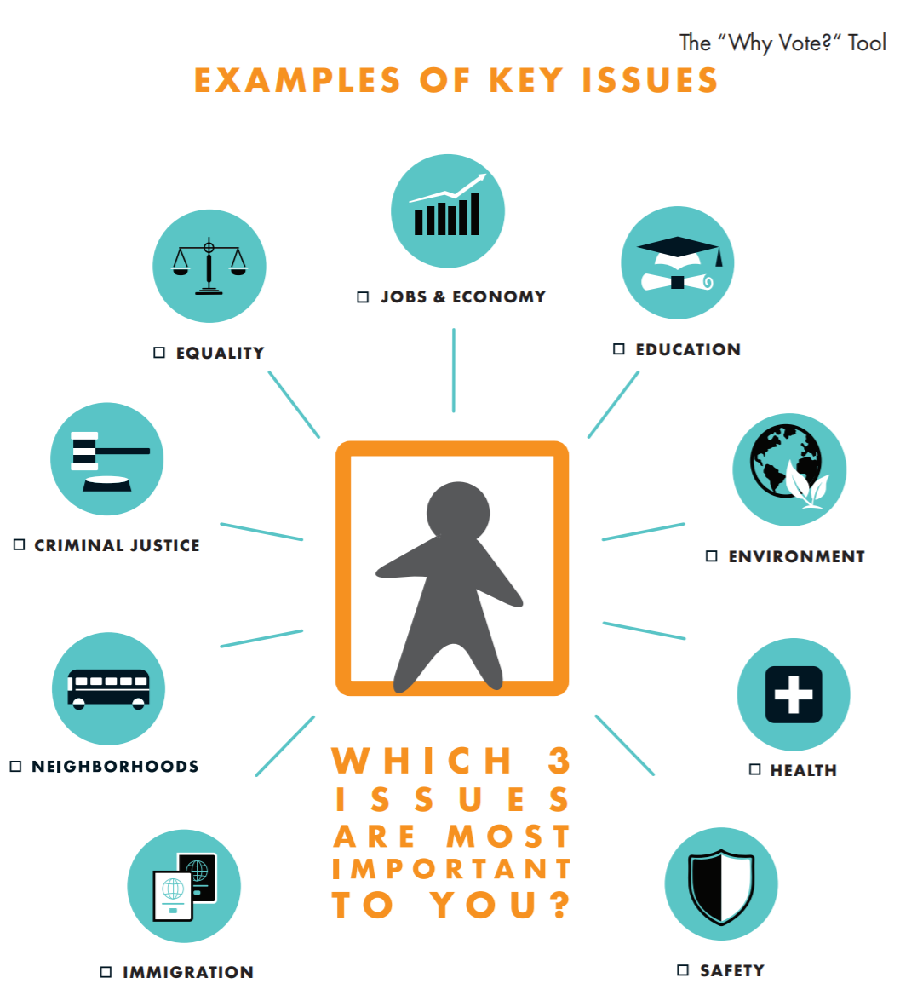

# Handout 3: Government Services/Key Issues

# Handout 4: Making Connections

1. Write an explanation of why the three issues/services you picked (from **Handout 3 Key Issues or Government Services)** are most important to you. Make sure to include an assertion, reasoning, and evidence in your response.

Your response should answer:

* Why is this issue/service important to you?
* What is an example of why this issue/service is important to you?
* How can this issue/service (negatively/positively) affect your neighborhood?
* From the issues you chose, which one is most important to you, and why?

|  |
| --- |
| *Write your argument here:* |

1. Elected officials make decisions that affect all these services and issues. Why would you/people like to have a say in who is making these decisions?

|  |
| --- |
| *Your answer:* |

# Handout 5: Question Formulation Technique (QFT)

**QFocus Prompt: Elected officials make decisions that affect all these issues/services. By voting, people can have a say in who’s making those decisions.**

*Rules for asking questions*

1. Ask as many questions as you can
2. Do not stop to judge, discuss, or edit the questions
3. Write every question exactly as stated or as it first comes to mind
4. Change any statements into questions

|  |
| --- |
| *Questions:* |

Definitions:

* Closed-ended questions can be answered with a “yes” or “no” or with a one-word answer.
* Open-ended questions require more explanation.

**Change** one close-ended question into an open-ended; change one open-ended into a close-ended one.

|  |
| --- |
|  |

**Prioritize** your questions:

1. Which three questions are most important for you to answer first and why?

|  |
| --- |
|  |
|  |
|  |

1. Which three questions are most important for you to affect decisions about the issues you care about?

|  |
| --- |
|  |
|  |
|  |

**Reflect:**

|  |
| --- |
| What did you learn today?  How can you use it? |

# Handout 6: Next Steps and Taking Action

Voting is not the only way to impact decisions that are important to you. Even if you are not eligible to vote, you can impact decisions, services, and issues that are important to you.

What are other ways beyond voting that people can impact decisions being made about the services/issues that are important to them? Name a specific method and an example if you have one.

|  |  |
| --- | --- |
| **Method of impacting decisions** | **Real-life example** |
| Advocacy   * *Email or call elected representatives* |  |
| Lobbying |  |
| Public protest |  |
| Civil disobedience |  |
| Social media |  |
| Call 311 |  |
| What else? |  |

**Next steps**

|  |
| --- |
| What would be your next steps to answering your most important questions? |
| What would you now like to know about voting? |
| What would you like to share with friends and family about what you learned? |

**Action plan**

Based on the list above and everything you’ve now learned, write down one action you plan to take now. What is one concrete way, even if it is small, that you will try to impact a decision that is important to you?

|  |
| --- |
| *Write down your action plan:* |