Lesson Planning Workbook:
for Using the Question Formulation Technique (QFT)

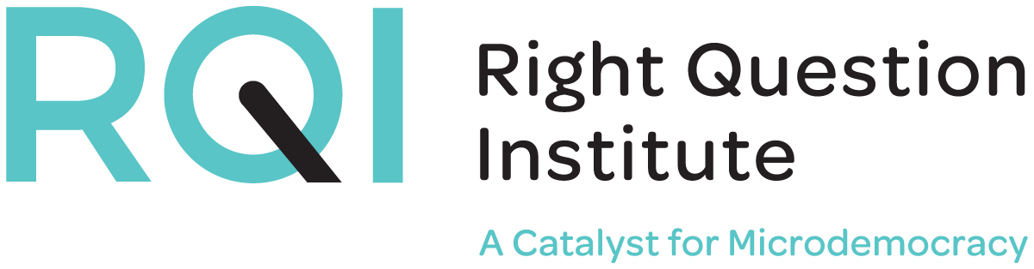

This resource may be reproduced or adapted, for noncommercial purposes, as long as it includes this reference: “Source: The Right Question Institute (RQI). The Question Formulation Technique (QFT) was created by RQI. Visit rightquestion.org for more information and free resources.”

We invite you to access our full range of free resources at rightquestion.org, including:

- Planning tools
- PowerPoint templates
- Classroom examples
- Instructional videos
- Downloadable free resources

We would like to thank The Sir John Templeton Foundation for their generous support of the Million Classrooms Campaign.

2464 Massachusetts Avenue, Suite 314, Cambridge, MA 02140
www.rightquestion.org
Follow us on twitter @rightquestion

Question Formulation Technique Planning Tool

The Question Formulation Technique (QFT) Planning Tool can be used to guide your thinking as you plan to use the QFT. The QFT Planning Tool will help to identify teaching and learning goals, consider how students’ questions may be used, design a Question Focus (QFocus), develop prioritization instructions, and create reflection questions.

Access this tool online at https://rightquestion.org/resources/field/education/

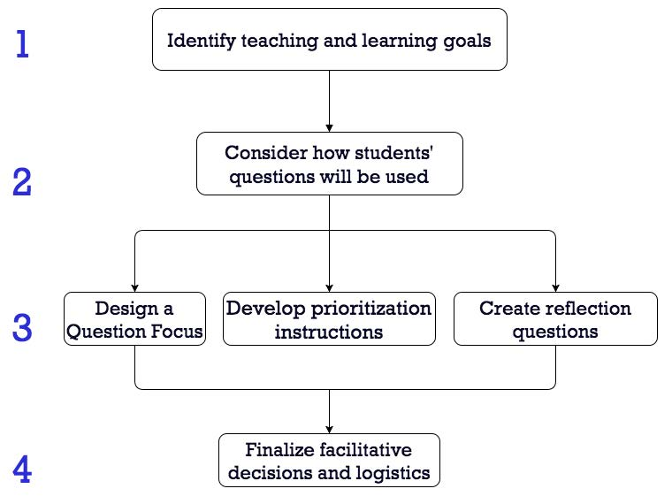
Finalize logistics

I. Identify teaching & learning goals
It is important to begin by thinking about what your students need to know, what you need to teach, and what you hope the QFT will help you achieve.

- What is the title of the lesson?

- Briefly describe the lesson.

- What are your teaching objectives for the lesson? This may include standards and content.

- At what point in the lesson will you use the QFT?

- Why are you using the QFT in this lesson?

II. Consider how students’ questions will be used
It is important to be clear about how students’ questions will be used before designing the QFocus, developing prioritization instructions, and creating reflection questions. For example, questions may be used as a pre-reading activity to stimulate curiosity and thinking about a new unit. They can use their questions to gather relevant information, guide a research paper, design a laboratory experiment, or solve a problem. You may use their questions for formative assessment (eg. checking for understanding), or even as a summative assessment (e.g generating unit test questions).

- How will students’ questions be used?

III. A) Design a Question Focus

The Question Focus (QFocus) is a stimulus for jumpstarting student questions; it is the focus for students to generate their questions. The QFocus may be anything as long as it is not a question, and it is related to the content you are teaching. The QFocus may be, a statement, phrase, a primary source, a visual, an aural aid, a math problem, etc. A good QFocus should be simple and clear about what students are asking questions (without any further explanation) and it should encourage divergent thinking.

- Brainstorm QFocus possibilities that are related to what you need to teach/what the students need to learn.

- Choose one of the QFocus options above and write it here:

- Quickly test the QFocus by naming some questions different students might ask.

- Troubleshoot your QFocus by filling out this chart.
 | Yes | No | Unsure
Is the QFocus a question?
Is there too much information?
Will the QFocus limit students to only one line of thinking?
Is there a word that might distract students?
Will the students perceive the QFocus as just another way of presenting the teacher’s message or ideas?
If you answer “yes” to any questions what are some ways you might you change your QFocus to sharpen it?

- Revise your QFocus based on your troubleshooting.
III. B) Design Prioritization Instructions

Prioritization instructions should bring students back to your teaching objectives and the plan for using student questions. Here are a few examples of prioritization instructions:

Choose 3* questions that…
- you consider most important
- will help you with your research
- can be used for an experiment
- will guide your writing
- can be answered as you read
- will help you solve the problem

*There are many benefits to allowing students to initially narrow it down to three rather than just one priority question. You may then ask them to select one of the three in order for them to, for example, write an essay, carry out a research project, or design an experiment.

- What instructions will you give to your students?

III. C) Design Reflection Questions

Reflection is an essential element of the Question Formulation Technique. It helps students name and reinforce what they have learned. Students get to do something they rarely have done before: reflect on their own learning and practice metacognitive thinking. You can have them do the reflection in different ways
- Small group discussion
- Individual reflection in writing
- Exit slip

- What format will you use for reflection?

Students may reflect on both process and content.
Examples of process reflection questions:
- What do you understand differently now about asking questions?
- How can you use what you learned about asking questions?
- How do you feel about asking questions?

Examples of content reflection questions:
- How did the QFT help you think about… (a key concept, an overarching topic, a theme in the unit, a chapter you just read)?

- What questions will you use to guide student reflection?

IV. Finalize facilitation logistics
It is important to consider what groupings may work best for your class. You may decide to group students differently as you move through the steps of the QFT.

- How will the students do their work?
 | Individually | Small Groups | Whole Class | Other
Discussing the rules
Producing questions
Categorizing questions
Prioritizing questions
Discussing next steps
Reflection

- Are there any other logistical adjustments that you would like to consider? (For example, who is recording questions, use of technology, etc.)

- You have planned how to use the QFT with an end goal in mind. Use this section to check your planning. Then, consider revising sections which may not help you meet your teaching and learning goals for the lesson.
 | Yes | No | Unsure
The QFocus will help to meet goals.
The prioritization instructions will help to meet goals.
The use of students’ questions will help to meet goals.
The reflection questions will help to meet goals.

Facilitation Principles for the Question Formulation Technique (QFT)
Facilitation Principles | What might be important or valuable about following this principle while facilitating the Question Formulation Technique (QFT)?
1. Monitor student adherence to the process

2. Do not give examples

3. Do not get pulled into group discussion

4. Acknowledge all contributions equally

- Reflection: Which principle might be most difficult for you to follow and why?

